Hazel Ortiz

ECO 602

Data exploration and deterministic functions

Q2: The histogram represents the distribution of elevation at the bird census types. That is, the types of elevation that were present at the areas where they took counts of the bird population for census. The spread of data was taken from 85m-872m. These exact numbers are taken from the metadata which tell us the basic information about the data, but you can see these numbers represented in the histogram as well but maybe not as precisely. You can see the peak of the data in the area with the tallest bars, so looking at the histogram data the peak is around 300m-450m. We can assume from this that there were more birds in the sampling areas that had elevations between 300m-450m than in other elevations. After 450m you can see there is a steep drop in the data, meaning that the higher the elevation, the smaller the population of birds found in the sampling sites.

It’s also important to look at the symmetry of the graph. The symmetry of the data can be seen in the distribution of this data. If the peak of the data is in the middle with symmetrical sides in the bars around it, the data is symmetrical. With our elevation histogram the data is slightly skewed to the left, given that the peak of the data is located on the left side.

Q3: The slope units are pin percent from 0%-110%.

Q4: Taking a look at the slope histogram, it is important to know that the slope represents the percentage of slopes that were in the sampling sites, areas where they took bird population counts for the bird census. The distribution of data from 0%-90% shows that the bird population is close to being evenly distributed; you can see that the bars on the histogram rise to the middle of the graph and then fall back down. It isn’t perfectly evenly distributed, however. Looking at the left side, there appears to be a higher concentration of birds found in sampling areas with 0%-50% slopes than the right side with 50%-110%. The peak of the data is where most of the individual birds were found for the census. It appears the birds were found most in areas between 40%-70% slopes since that is the are in the graph where the bars are highest. It appears birds where most commonly found in flat to mid-level slopped areas rather than the higher peaks.

Q5: The final histogram describes the aspect of the sampling sites/ areas where the bird’s population census. The aspect describes the direction the slope is facing from a bird’s eye view. Like looking at a compass: North is 0, East is 90, South is 180, and West is 270. The aspect is described in degrees just like it would be on a compass, with the values from 0-360.The sampling distribution seems to not be evenly distributed but rather uniformly distributed since there is not clear peak and drop in data. So, looking at the data and what we know are the degree points for the four directions, the data shows that the sampling sites tend to have more north and west facing slopes. There is a bit of a dip in the data towards the middle of the histogram, around an estimated 140- 220 degrees, showing that there is slightly fewer sampling sites in the south-east, south, south-west facing slopes.

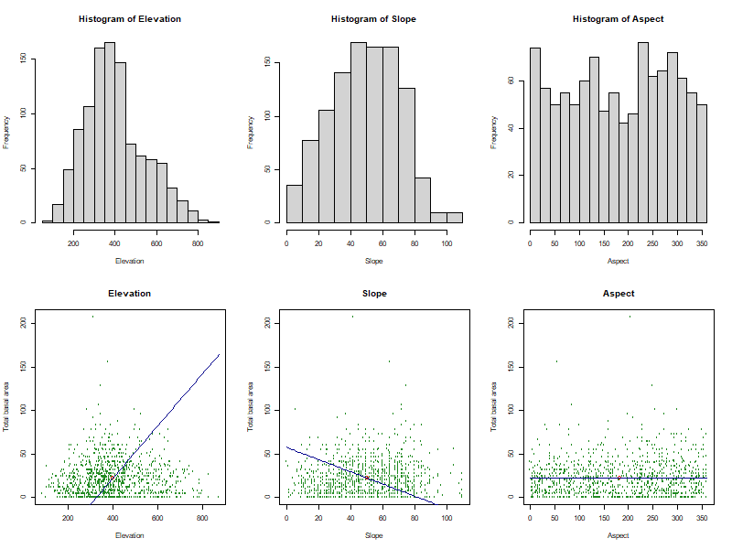

Q8: Looking at the scatterplots, together all three seem to not have a strong association between the variables. There is not a linear trend in either of the three plots. There are areas in all the scatterplot, particularly in elevation, where there is a cluster of data that shows a slight trend. I fit my linear model on the elevation plot with the direction of the clustered data. However, in the elevation histogram I am not sure that this is the best fit for the model because based on my visual assessment it doesn’t seem like there is a positive linear trend as my linear model shows. In my slope plot, I followed the same thinking and fit my linear model to the trend of the clustered data, which is a little less obvious in this one. The cluster in the slope build up towards the middle and then fall with the higher percentage of slope, so I think this model fits a little better but not great since there is little association. The aspect plot I think makes the most sense as a fit because even though there is not much association, the trend of the plot is pretty straight forward and unitary, so I fit my linear model to match.